Year Two
Writing purpose | Text | Writing Outcomes | NC Objectives
Autumn 1 |  | Narrative -to entertain | Segmenting spoken words into phonemes and representing these by graphemes, spelling many correctly.
Autumn 1 |  | -setting description  (to entertain) | ‘because’  ‘and’
Autumn 1 |  | Character descriptions  (to entertain) | Possessive apostrophe
Autumn 1 |  | Rosa Parks Fact File  (to inform) | Contracted form
Autumn 2 |  | Narrative  (to entertain) | -ly  -(but, or, because)
Autumn 2 |  | Setting Description  (to describe) | Learning new ways of spelling phonemes for which one or more spellings are already known (soil, great, many)
Autumn 2 |  | Email writing  (to recount, inform and inquire) | Contracted form  Learning to spell common exception words
Spring 1 |  | Character descritpion  (to entertain) | -Use a range of suffixes (-ly,-ful and –less)
Spring 1 |  | Persuasive letter writing  (to inform) | Learning to spell common exception words
Spring 1 | 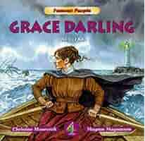 | Diary Entry (1st person)  (to recount) | Contracted forms  Learning new ways of spelling phonemes (lighthouse, keeper, wreck, rescue)
Spring 2 |  | Character description  (to describe and entertain) | Possessive apostrophe  Learning new ways of spelling phonemes for which one or more spelling is already known.
Spring 2 |  | Setting, alternative ending  (to describe and entertain) | Segmenting spoken words into phonemes and representing these by graphemes, spelling most correctly.
Spring 2 | Spring Poetry | Acrostic poems  (to entertain) | Distinguish between homophones and near homophones.
Summer 1 |  | Newspaper report  (to inform and inquire) | Possessive apostrophe  Add suffixes to spell longer words (ment, ly, ful)
Summer 1 | 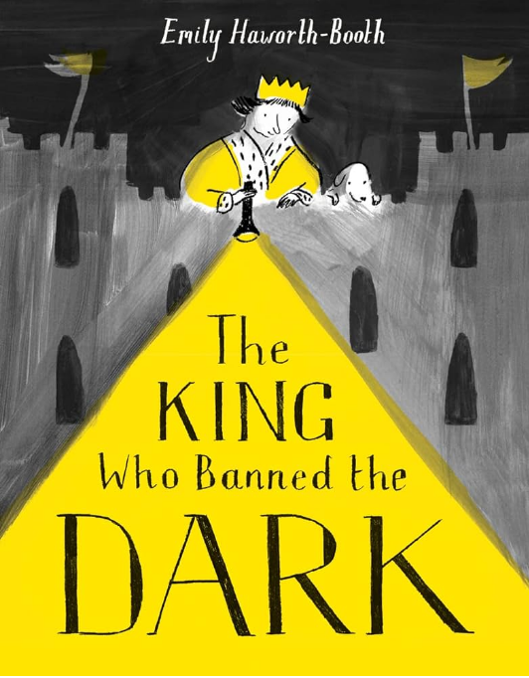 | Narrative  (to entertain) | Add suffixes to spell longer words: -ness, ful, -ment
Summer 1 | 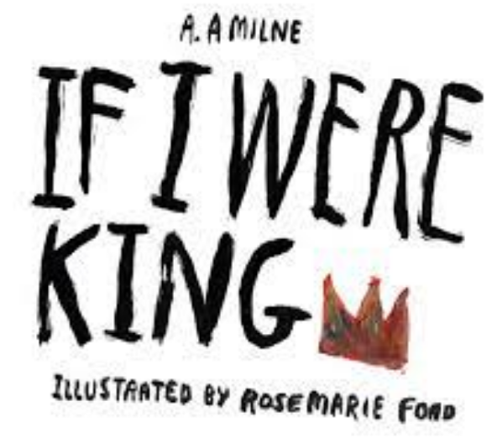 | Poem  (to entertain) | Possessive apostrophe  Distinguish between homophones and near homophones.
Summer 2 |  | Narrative  (to entertain) | Spell using the possessive apostrophe (singular)  Add suffixes to spell longer words (-ment, -ness, -less)
Summer 2 | School trip recount | Recount of real events  (to recount) | Suffix ly  Segmenting spoken words into phonemes and representing these by graphemes, spelling many correctly.

