 |  |  | Year One
Writing Purpose | Text |  |  | Writing outcome | NC objectives
Autumn 1 |  |  |  | Colourful semantics  Sequencing a story | Phonetic spelling  Naming the letters of the alphabet in order
Autumn 1 |  |  |  | Character description | Phonetic spelling  Adjectives
Autumn 1 |  |  |  | Short narrative  Shared writing  Past tense | -ed  Apply simple spelling rules
Autumn 2 |  |  |  | Email writing | -s and –es  ‘and’  First person ‘I’
Autumn 2 | 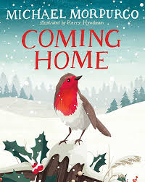 |  |  | Setting description  Short narrative with guided write | -ing  Compound words
Autumn 2 | 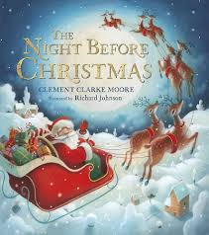 |  |  | Short poem | Adjectives  Rhyming words
Spring 1 |  |  |  | Prediction of the ending  Short Narrative | -ing and –est  Common exception words (went, was, he)
Spring 1 |  |  |  | Diary entry | Days of the week  -using s and –es (boats, houses, buckets)  -suffix er and est (bigger, stronger, furthest, quickest
Spring 2  Alternative ending | 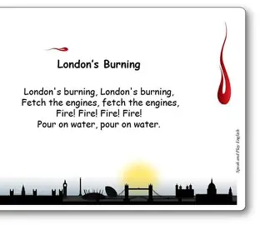 |  |  | Poetry  Shared writing | Common exception words  Spelling on repeated words
Spring 2  Alternative ending |  |  |  | Setting description | Plurals s and –es  Using letters of the alphabet to distinguish between alternative spellings of the same sound.
Spring 2  Alternative ending |  |  |  | Fact file about London | Naming the letters of the alphabet in order  Common exception words
Spring 2  Alternative ending |  |  |  | Creative writing  Literacy shed | Using letter names to distinguish between alternative spellings of the same sound.
Summer 1 |  |  |  | Newspaper report | Suffix -er, -ed  Days of the week
Summer 1 |  |  |  | Informal letter writing | Prefix –un  Using the letter names to distinguish alternative spelling of the same sound.
Summer 1 |  |  |  | Persuasive letter writing | Apply simple spelling rules  Naming the letters of the alphabet in order
Summer 2 | 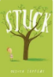 |  |  | Alternative ending | Pre-fix –un  Apply simple spelling rules
 |  |  |  | Instruction writing  How could we improve our school. | Days of the week  Suffixes (-ing, -er, -est, -ed and –er)

