Term 1 | Texts | Communication and language | Physical development  Fine motor | Literacy | Weekly writing focus
Autumn 1 | 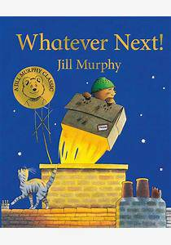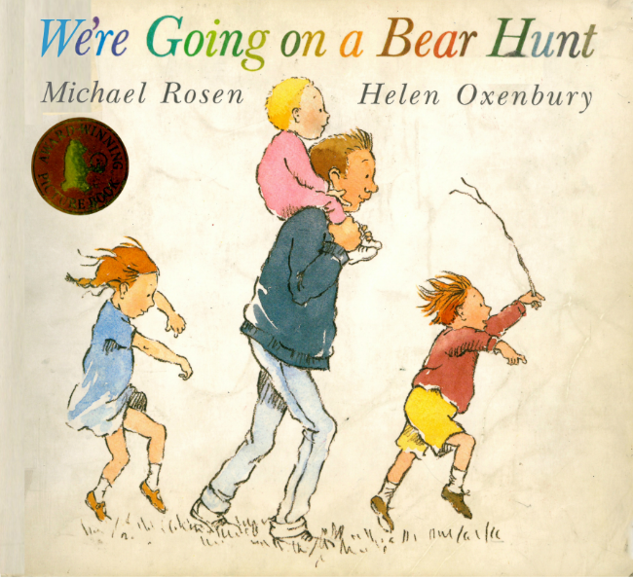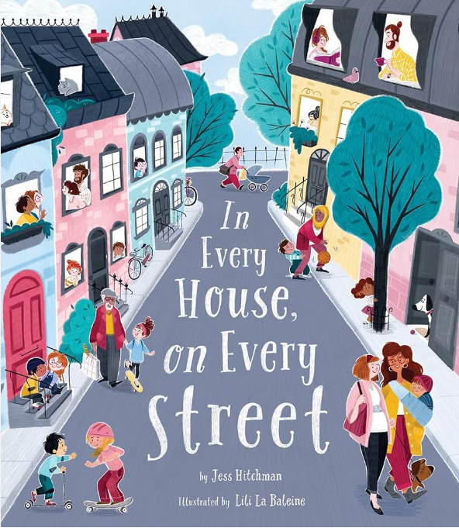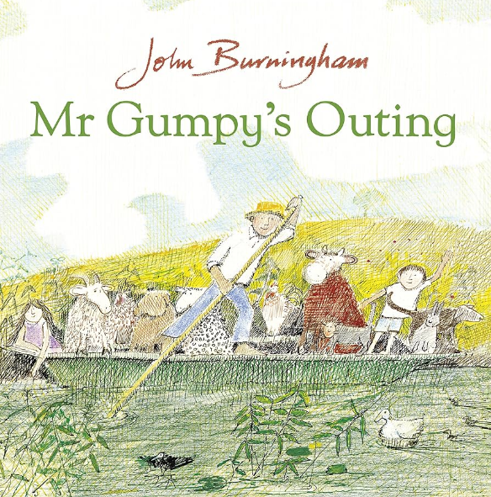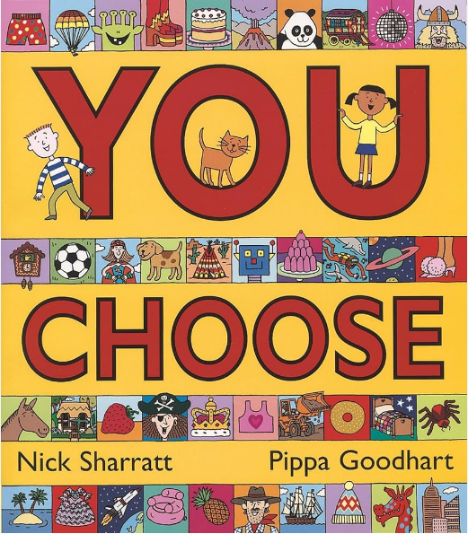 | Listening, Attention and Understanding:  Children will be able to understand how to listen carefully and know why it is important.  Speaking:  Children will talk in front of small groups and their teacher offering their own ideas. | Use a range of small tool, including scissors, paint brushes and cutlery. | Word Reading  Children will segment and blend sounds together to read words.  Comprehension  Children will independently look at a book, hold it the correct way and turn pages.  Writing  Children will give meanings to the marks they make. | To suggest how the story might end.  To use pictures to sequence a story  To act out a story.  To use pictures to tell a story.  To begin to predict what might happen in a story.  To tell a story through drawing and emergent writing.
Autumn 2 | 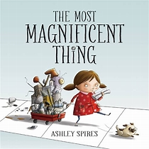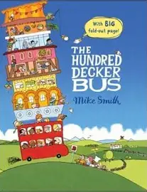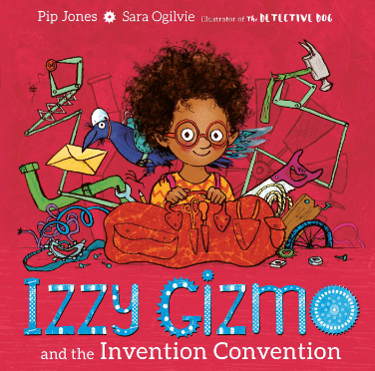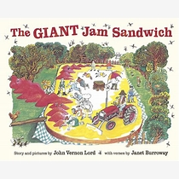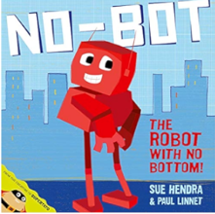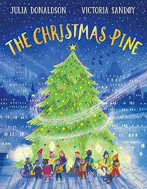 | Listening, Attention and Understanding  Children will begin to understand how and why questions.  Speaking  Children will offer thier own ideas using newly learned vocabulary. | Use a range of small tool, including scissors, paint brushes and cutlery. | Word Reading  Children will begin to read captions and sentences.  Comprehension  Demonstrate an understanding of what has been read to them by retelling stories.  Writing  Children will form recognisable letters, most of which are formed correctly. | To draw from a story using drawing club.  To draw their own invention and label.  Draw with a purpose, drawing club.  To retell a story using a story map.  To use simple words from a text.  To predict what might happen next.  To write a simple phrase.
Term 2
Spring 1 | 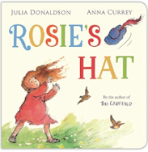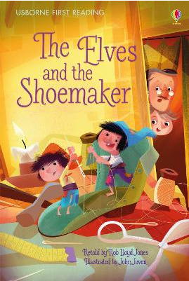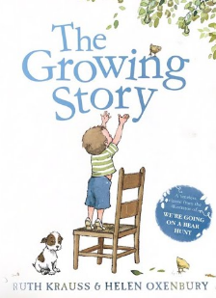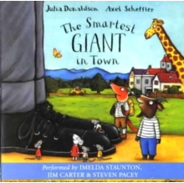 | Listening, Attention and Understanding  Children will learn to ask questions to find out more.  Speaking  Children will express thier feelings and ideas using full sentences, including conjunctions.  Children will use the correct tense when talking about different time periods. | Begin to show accuracy and care when drawing. | Word Reading  Children will recognise taught digraphs in words and blend the sounds together.  Comprehension  Children will act out stories using recently introduced vocabulary.  Writing  Children will write words representing the sounds with a letter(s) | To order a story using key vocabulary.  To retell a story using text specific vocabulary.  To make verbal observations about items/person.  To read simple phrases aloud.  To talk about how characters might feel.
Spring 2 | 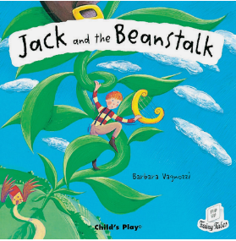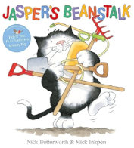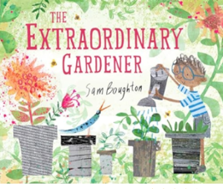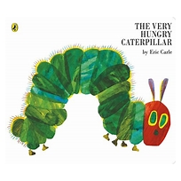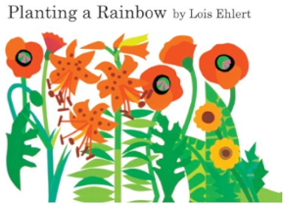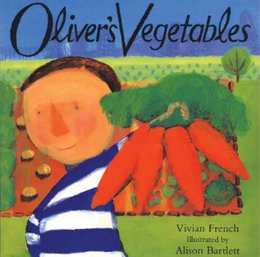 | Listening, Attention and Understanding  Children will retell a story and follow a story without pictures or props.  Speaking  Children will offer explanations for why things happen making use of new vocabulary. | Begin to show accuracy and care when drawing. | Word Reading  Children will read words containing common exception words and digraphs,  Comprehension  Children will be able to anticipate key events in the story.  Writing  Children will write labels/[phrases representing the sounds with a letter(s) | To sequence a story.  To make predictions about a text.  To listen to a story and remember a few details.  To use phonics to write thier own version of a story.  To write on my own.  To use phonics to write.
Term 3
Summer 1 | 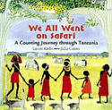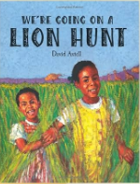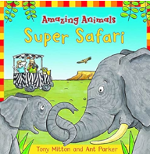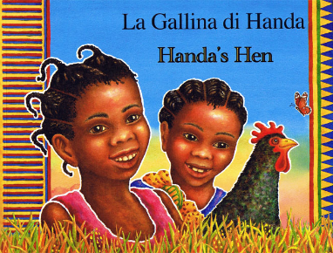 | Listening, Attention and Understanding  Children will be able to make comments and understand a question such as who, what, where, when, why and how.  Speaking  Children will use talk to organise, sequence and clarify thinking, ideas, feelings and events. | Hold a pencil effectively in preparation for fluent writing-using tripod grip in almost all cases. | Word Reading  Children will say a sound for a least 10 diagraphs and each letter of the alphabet.  Comprehension  Children will discuss/retell a story using text vocabulary during different times of the day.  Writing  Children will write words which are spelt phonetically. | To identify words that begin with the same letter.  To describe characters from the text.  To join in with repeated phrases.  To discuss the layout of a non-fiction text.  Assessment: To write a sentence.
Summer 2 | 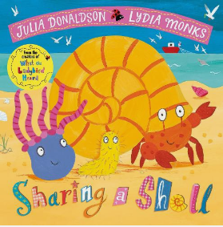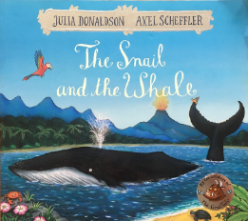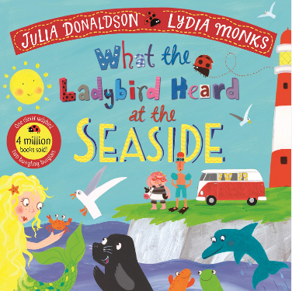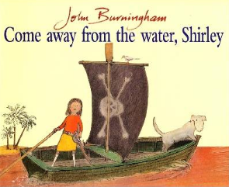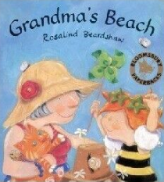 | Listening, Attention and Understanding  Children will be able to engage in conversation about the text with peers and the teacher.  Speaking  Children will offer their own ideas using key vocabulary with modelling from the teacher. | Hold a pencil effectively in preparation for fluent writing-using tripod grip in almost all cases. | Word Reading  Children will read longer sentences containing taught sounds including common exception words.  Comprehension  Children will verbally retell narratives using their own words.  Writing  Children will write simple phrases and sentences that can be read by others. | To write a character description.  To identify words that rhyme.  To describe a character.  To use tricky words in a sentence.  To use phonics to label a text.

