 | Whiteboards & book  LW - Focus letter | Fine motor | Scissor control | OT assessment
Week 1 | it |  | 1 | 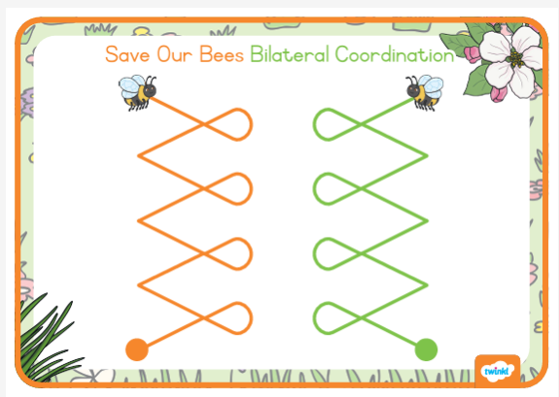
Week 2 | tl |  | 2
Week 3 | uy | 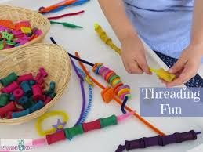 | 3 | 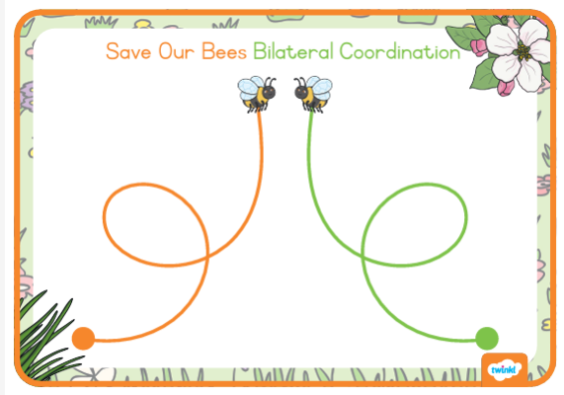
Week 4 | jy |  | 4
Week 5 | b | 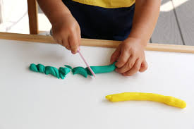 | 5 | 

