Member of staff responsible | Caroline Sheppard
Date Policy Produced | Autumn 2022
Policy agreed/last reviewed | Spring 2026
Next review date | Spring 2026
Other Related Policies | n/a
Is it a Statutory Policy? | no
Does it need Governor approval? | no


Music Policy
West Byfleet Infant School
We Belong, Inspire, Succeed

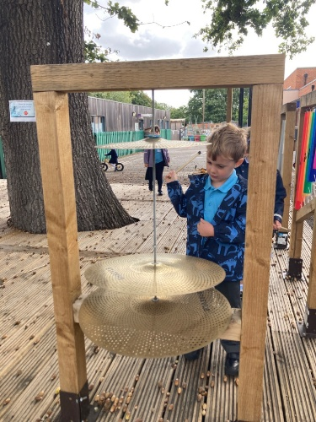

Our school vision is ‘We Belong, Inspire, Succeed’. This reminds us daily that children need to feel safe and secure within the school community, have opportunities to inspire their interests and an enthusiasm for learning, as well as achieving success at all levels.
At West Byfleet Infant School, we believe that music is a unique way of communicating that can inspire and motivate children. It is a vehicle for personal expression, and it can play an important part in children’s personal development. Music reflects the culture and society we live in, and so the teaching and learning of music enables children to better understand the world they live in. Besides being a creative and enjoyable activity, music can also be a highly academic and demanding subject. It also plays an important part in helping children feel part of a community. We provide opportunities for all children to create, play, perform and enjoy music, to develop the skills, to appreciate a wide variety of musical forms, and to begin to make judgements about the quality of music.

Music Curriculum Aims:
- To develop an enjoyment & appreciation of all music, including recognition of different types of music.
- To develop the ability to listen & appraise music, including knowledge of musical history, our diverse musical heritage and traditions & a variety of composers & their work.
- To develop the ability to perform music.
- To develop the ability to improvise and compose music with understanding.

Music Teaching & Learning Approach:

At West Byfleet we believe in making music an enjoyable learning experience. We encourage children to participate in a variety of musical experiences. These are drawn from the Kapow Primary Music platform as well as Out of the Ark stage shows, through which we aim to build the confidence of all children. Singing lies at the heart of good music teaching and the whole school take part in weekly singing assemblies as well as in class provision. Our teaching focuses on developing the children’s ability to sing in tune and with other people. Through singing songs, children learn about the structure and organisation of music. We teach them to listen to and appreciate different forms of music. Children develop descriptive skills in music lessons when learning about how music can represent feelings and emotions. We teach children to make music together, to understand musical notation, and to compose pieces.

We formalise this approach using the following five key areas of skills and knowledge.
- Listening and evaluating – expressing musical preferences; exploring the impact of musical ideas; understanding how effects are created by combining musical elements.
- Creating sound – exploring the children’s vocal skills; developing skills to manipulate sounds on a range of instruments.
- Notation – recognising the basics of musical notation; reading simple rhythmic patterns; developing the foundational knowledge of how staff and graphic notations can communicate music.
- Improvising and composing – creating and refining the children’s own music through improvisation and notation; experimenting with styles and features; employing musical concepts to add interest.
- Performing – using voices expressively; developing instrumental control and expression; performing as part of a group.
At West Byfleet Infant School we teach our children to:
- Use their voices expressively by singing songs and chanting rhymes.
- To be able to control sounds made by the voice and a range of tuned and untuned instruments.
- Listen with concentration, explore and recognise musical elements.
- To perform with others and develop an awareness of audience, venue and occasion.
- To compose in response to a variety of stimuli.
- To communicate musical ideas to others.
- To listen to and develop an understanding of music from different times and cultures.
- To respond to and evaluate both live and recorded music; including their own and others compositions.
- To ensure that Music is an enjoyable and enriching learning experience.

Reporting to parents:
Parents are informed formally of children’s progress at twice yearly Parents’ Meetings and through the end of year report. Staff are always available for informal chats as and when they are thought to be appropriate from either the teacher or parent.

