Member of staff responsible | Early Years Lead – Jess Martin
Policy agreed/last reviewed | September 2025
Next review date | September 2026
Other Related Policies
Is it a Statutory Policy? | Yes
Does it need Governor approval? | Yes - C&L Committee

West Byfleet Infant School
We Belong, Inspire, Succeed

Early Years Foundation Policy
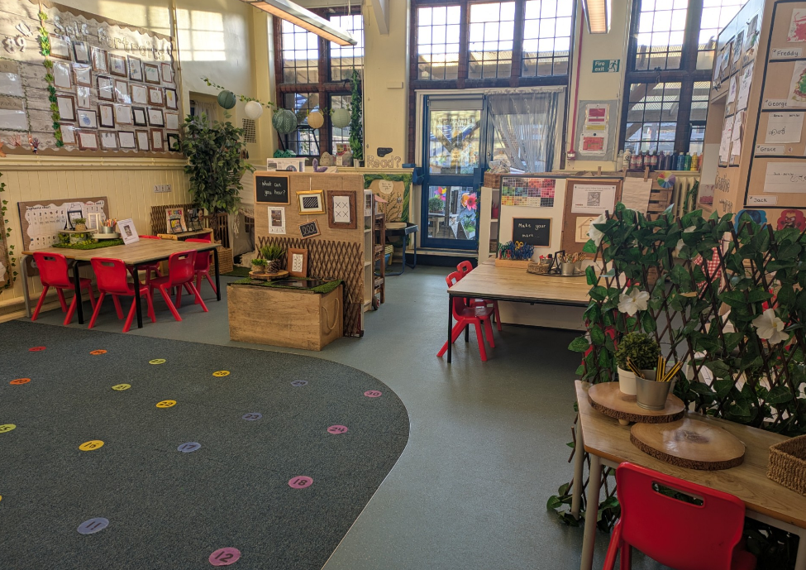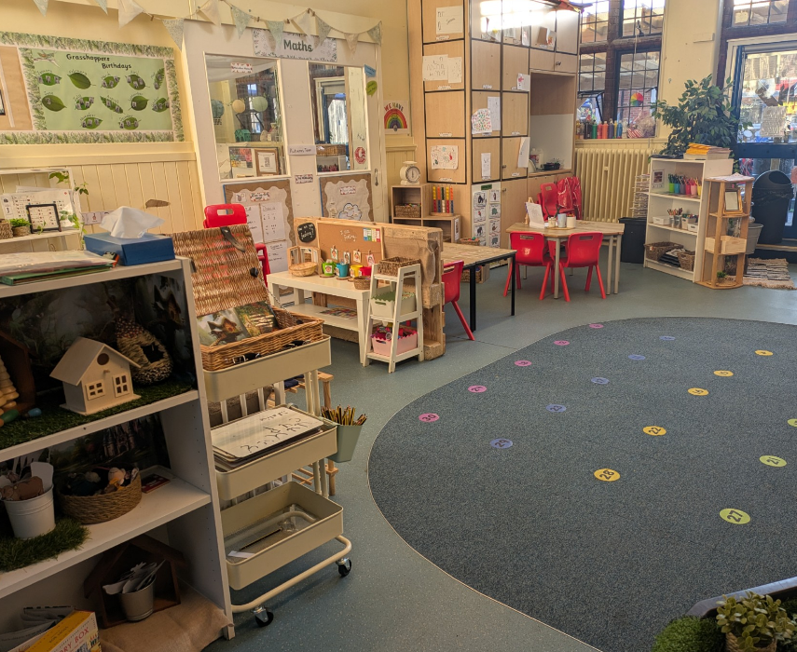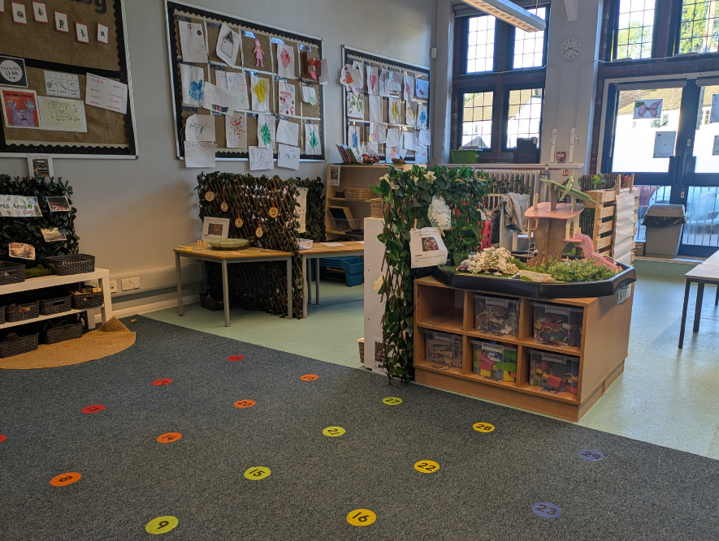

Our school vision is ‘We Belong, Inspire, Succeed’. This reminds us daily that children need to feel safe and secure within the school community, have opportunities to inspire their interests and an enthusiasm for learning, as well as achieving success at all levels.
The Early Years Foundation Stage framework identifies the essential role of play in a child’s development. It is through both child-led play and play guided by an adult that children develop confidence and relationships with others. Through play, our Early Years Team will support the children to become independent, enthusiastic learners who are able to challenge themselves, persevere and reflect on their learning.

The Characteristics of Effective Learning are the focus of our Early Years environment to allow children to have the best start to their educational journey. We work closely with other Early Years settings and parents to ensure there is a collaborative approach where all children can flourish.

Early Years Foundation Stage Policy
Rationale
We believe the Early Years Foundation Stage (EYFS) plays a vital role in laying the foundations for lifelong learning. Our aim is to support every child in developing physically, verbally, socially, cognitively, and emotionally, while fostering a lifelong love of learning.
We are committed to nurturing confident, curious learners who feel a strong sense of belonging; empowering them to take risks, explore new ideas, and thrive. Taking a holistic approach, we value each child as a unique individual and are passionate about helping all children reach their full potential.
EYFS Statutory Framework
Aims
“The EYFS is about what children learn, as well as how they learn. Effective practice is a mix of different approaches. Children learn through play, by adults modelling, by observing each other and through adult-guided learning”

(Statutory Framework for the Early Years Foundation Stage - March 2024)
We aim to provide a relevant and engaging curriculum through well-planned, purposeful activities, both child-initiated and teacher-led, to ensure every child reaches their full potential, regardless of their starting point. Our environment promotes a positive and confident attitude to learning, built on mutual respect and high expectations.
We are committed to challenging each child appropriately, supporting them to succeed and thrive from their individual starting points. Our project-based curriculum places play and exploration at its core, enriched by a wide range of first-hand experiences such as educational visits and guest visitors. These shared experiences inspire curiosity and provide meaningful opportunities for children to develop language, knowledge, and skills.
We recognise parents as a child’s first educators and actively seek to build strong, supportive partnerships. Initiatives such as Parent Workshops, weekly website updates, Tapestry (parent view), Creative Projects, and the Lending Library ensure ongoing communication and collaboration.
To help children recognise and celebrate their learning, we embed the Characteristics of Effective Learning throughout our practice: Playing and Exploring, Active Learning, and Creative and Critical Thinking. Using the ‘Learning Zoo’ as a reflective tool, children are encouraged to independently evaluate their progress and understand what makes them successful learners.
Staffing
All practitioners within the unit work collaboratively to deliver the EYFS curriculum, fostering a consistent and cohesive approach to teaching and learning. Regular communication takes place throughout the school day and during team meetings, ensuring a shared understanding of planning, delivery, and outcomes. Staff agree on strategies that promote consistency and continuity for the children.
Learning Support Assistants (LSAs) play a vital role in supporting children’s development across the curriculum, working with both individuals and small groups. Their time is carefully structured on a weekly and daily basis, with clear objectives provided for each activity. LSAs communicate regularly with class teachers, either through formal records or professional discussion, to ensure continuity of assessment and planning.
They are given access to planning documents and are actively encouraged to contribute ideas and feedback, helping to refine and enrich planned activities. Each plan clearly outlines the intended learning outcomes, enabling LSAs to effectively support and extend learning.
All staff are involved in both guided activities and play-based learning, promoting development through meaningful interactions.
New LSAs are supported through role modelling, clear guidance, and opportunities for professional development. They are encouraged to share their ideas, attend relevant training, and become fully integrated into the planning, delivery, and evaluation of children’s learning and progress
Learning environment
The EYFS unit consists of three classrooms and an extended outdoor area, all of which are directly accessible to the children. We operate a free-flow environment, allowing children to move freely between indoor and outdoor spaces, as well as across the three Reception classrooms. Resources and equipment are shared across the unit, fostering collaboration and consistency in learning.
Our classrooms are designed to be calm, neutral, and inviting, with engaging spaces that support focused and purposeful learning. Displays are regularly updated, and working walls are used to encourage children to revisit and reflect on their learning. Each child has a dedicated space on the 'WOW Squares' display to celebrate and showcase a personal achievement or significant piece of work.
Role-play areas are themed to reflect current projects or children’s emerging interests, informed by careful observations during play. We strive to create a stimulating, creative learning environment that promotes exploration and curiosity.
Both the indoor and outdoor areas are set up to provide continuous and enhanced provision across all areas of learning. Children are encouraged to be independent, confidently selecting the tools and materials they need to support their learning and development.
Teaching strategies
Learning in the early years is a rewarding and enjoyable experience, where children are encouraged to explore, investigate, discover, create, practise, rehearse, repeat, revise, and consolidate their developing knowledge, skills, understanding, and attitudes. Throughout the Foundation Stage, these elements are brought together most effectively through play and meaningful conversation through skilled interactions.

Teaching in the early years involves more than delivering content, it is about systematically supporting children to make connections in their learning. Practitioners guide children forward in their development, encouraging reflection on prior learning while fostering new understanding.
Effective teaching and learning strategies should be varied and flexible, carefully adapted to meet the individual needs, interests, and developmental stages of each child. This responsive approach ensures that all children are supported, challenged, and inspired throughout their early learning journey.
This is achieved in a variety of ways:
- Direct teaching of knowledge and skills in whole class and group activities,
- Using conversation and carefully framed questions,
- Motivating children to concentrate, to persevere and to try several ways to make something work,
- Enabling children to learn based on knowing what they can do, identifying what comes next, knowing when to intervene and when to hold back,
- Skilful and well-planned observations of children – through objective led planning approach,
- Assessing children’s development and progress and identifying the next steps in their learning
- Reflection of learning through the use of the Learning Zoo’s Characteristics of Effective Learning.
Curriculum
The EYFS follows the Statutory Framework for the Early Years Foundation Stage (March 2024). Our curriculum is designed to support children in meeting the end of year goals outlined in the EYFS Statutory Framework.
The EYFS play-based curriculum is intended to give the children a wide range of experiences in all seven areas of learning, these are split into Prime and Specific areas:
PRIME -
- Personal, Social and Emotional development
- Communication and Language
- Physical Development
SPECIFIC -
- Literacy
- Mathematics
- Understanding of the World
- Expressive Arts and Design
The PRIME areas are a fundamental part of the EYFS and the embedded skills within these areas will allow children to be successful within the SPECIFIC areas. These areas are a central focus in planning and delivery of sessions, observations and developments in children.
Personal, Social and Emotional Development
Personal, Social and Emotional Development is central to a child’s overall well-being and underpins success in all other areas of learning. This area focuses on helping children understand and manage their emotions, develop a strong sense of self, build positive relationships, and gain the confidence to explore and engage with the world around them.
Through a nurturing and inclusive environment, children are supported in forming constructive relationships with both peers and adults, within school and in the wider community. Activities are carefully planned to promote emotional, moral, spiritual, and social growth alongside intellectual development.
Children are exposed to positive role models and diverse representations that challenge stereotypes and encourage respect for differences in gender, ethnicity, religion, special educational needs, and disabilities. They are also provided with meaningful opportunities to build independence, make choices, and take responsibility, laying the foundations for resilience, empathy, and a lifelong positive attitude toward learning.
Communication and Language
The development of communication and language is fundamental to all areas of learning and lies at the heart of young children’s development. Communication begins with non-verbal cues, such as body language and facial expressions, and evolves as children learn to listen, understand, and speak. These essential skills grow as children express their needs and feelings, engage with others, and begin to form their own identities and personalities.
Strong communication skills enable children to participate confidently and meaningfully in their communities, both now and in the future. In our setting, each aspect of this area; listening, attention, understanding, and speaking, is carefully planned for, with a focus on providing rich, language-rich environments with a key focus on vocabulary development and oracy skills. Children’s individual needs, starting points, and interests are always taken into account to ensure every child is supported and challenged appropriately.
We give all learners the opportunity to:
- communicate thoughts, ideas and feelings
- build up relationships with those around them
- share and enjoy a wide range of music, rhymes, stories, poetry and non-fiction
- link language with physical movement in action songs and rhymes, role play and practical experiences such as The Poetry Basket, gardening and cooking
- see the importance of language in signs, notices and books
- develop spoken language through conversations with other children and adults

Physical Development
Physical Development focuses on improving children’s coordination, control, manipulation, and movement through both fine and gross motor activities. Our aim is to help children build confidence in their physical abilities while developing an understanding of the importance of health, fitness, and an active lifestyle.
Children are given time and space to explore, experiment, and refine their movements in a safe, well-planned, and well-resourced environment, both indoors and outdoors. They are encouraged to engage all their senses and respond to a wide range of stimulating experiences that promote physical growth and body awareness.
Through purposeful play and adult-guided activities, children develop the physical skills necessary for everyday tasks, such as writing, dressing, climbing, balancing, and using tools with increasing control. Our approach nurtures not only physical competence but also resilience, independence, and a positive attitude toward being active.
Play
Well-planned play, both indoors and outdoors, is one of the most effective ways young children learn. Through play, children explore, experiment, and make sense of the world around them in meaningful and engaging ways.
We provide opportunities for children to play in a variety of contexts: independently, in pairs or small groups, quietly or energetically, and with or without adult guidance. In a secure and supportive environment, play allows children to represent and deepen their learning experiences, promoting cognitive, social, emotional, and physical development.
Through play, children learn self-regulation, develop social skills, and begin to understand the importance of rules and boundaries. They are encouraged to take risks, learn from mistakes, think creatively and imaginatively, and communicate effectively with others. Adult support during play ensures that learning is extended and tailored to each child’s needs and interests, making play both purposeful and powerful.
Outdoor Learning Area
The EYFS unit features a secure, large enclosed outdoor area situated beside the classrooms, designed to support children’s learning through free play and targeted enhancement activities based on ongoing observations. Most of the space is surfaced with tarmac, and a covered canopy provides shelter, allowing children to engage in outdoor learning and play regardless of weather conditions.
We view the outdoor area as a vital extension of the classrooms. Children experience a wide variety of activities outdoors, including maths and literacy games, construction play, physical challenges, and scientific investigations. Adults actively participate during outdoor play, supporting children’s ideas, deepening their learning, and encouraging connections across different areas of development.
Our approach promotes equal access and participation for all children, regardless of gender or additional needs. We also focus on developing essential social skills such as cooperation and communication. While children are encouraged to spend time outside regularly, we respect individual preferences, no child is ever forced to participate against their will.
Outdoor learning is fully integrated into our weekly planning, which addresses a broad spectrum of skills and topics tailored to meet the diverse needs of all children in the unit.
Induction
At West Byfleet Infant School, we are committed to making the transition from children’s previous settings; whether home, nursery, or playgroup, as smooth and stress-free as possible for both children and their carers. Families considering a placement are warmly encouraged to visit the school, where they receive a comprehensive presentation and guided tour. There is ample opportunity to discuss any confidential concerns or questions.
In the term before admission, carers are invited to an information meeting where all relevant details about their child’s entry into school are shared. Additionally, children are invited to attend ‘Play and Stay’ sessions in the EYFS Unit alongside their carers, providing a gentle introduction to the school environment and helping to ease any anxieties.
To ensure continuity, staff from previous settings are invited to meet and share important developmental information about children joining us. We also maintain close communication with nurseries and speak directly with key workers to build a full picture of each child before they arrive.
School entry has a short staggered start to allow practitioners to give each child the individual attention they need for a confident and positive start. Carers are encouraged to leave once their child is happily settled, and we welcome any concerns parents may have, offering reassurance and honest communication at all times. We value parent feedback on the induction process and continually review and improve it to best meet the needs of children and families year after year.
Inclusion
We are committed to providing learning opportunities that set realistic yet challenging expectations tailored to meet the diverse needs of all children.
Our curriculum is carefully planned to support children of all genders, those with special educational needs and disabilities, children who are more able, and those from a wide range of social, cultural, religious, ethnic, and linguistic backgrounds.
We strive to create a supportive and inclusive learning environment where every child’s contribution is valued and respected. By celebrating diversity and promoting equity, we ensure all children have the opportunity to thrive and reach their full potential.
Health and Safety
We believe it is essential to provide a safe and secure environment for all children in our care. We adhere strictly to the school’s Health and Safety policy, and from their first day, children are taught simple safety procedures for using equipment and moving safely around the school.
Our premises and equipment undergo regular inspections to ensure they meet safety standards.
Additionally, we have specific rules governing the use of both indoor and outdoor learning areas, detailed in our dedicated Early Years risk assessment, which all staff are fully familiar with and follow consistently.
Partnership with parents
Parents’ fundamental role in their child’s education is recognised and acknowledged by staff and we aim to build a partnership based on shared responsibility, understanding and mutual respect. We acknowledge parents/carers as the child’s first, continuing and most influential educators. We believe it is vital that there is two-way communication between parents and school for successful education. We listen to and respect parents’ views of their children and their development, and encourage a partnership between home and school.
We encourage informal and planned discussion with parents. Teachers are available at the start/end of the school day for short informal discussion, and longer meetings can be arranged by appointment at any time. Parents are encouraged to share confidentially with staff any factors at home that might affect their child’s happiness or progress.
Prior to their child starting school, carers are invited to a meeting when the curriculum is explained and they are told how they can support this at home. We encourage parents to support the curriculum in a variety of ways - including learning phonics and core words, reading practice and exploring number concepts such as counting to 20 and back or counting sets of objects.
The learning projects we explore each half term throughout the year are shared via the school website. In addition, on the year group page of our school website, we also share a weekly summary of what the children have been learning about in Reception. This can then be translated on screen into numerous different languages to support our parents who do not have English as their first language.
Parents are invited to a half-termly ‘Parent Workshop’, once the children have settled in school, where they engage in activities alongside their children. The focus is linked to a different area of learning each time – and provides an opportunity for parents to share in the learning process.
We offer a formal Parents Evenings twice a year, where carers and parents can book an appointment to come and speak to the class teacher and view their child’s work. If either the parent or teacher has concerns about any aspect of the child’s progress or welfare, it is hoped that this will already have been dealt with, so Parents Evening should hold no surprises.
A written report is given in the Summer term. As needed, throughout the year, we share the results of any assessments from outside agencies of the children and the internal assessments are available on request. Parents are able to email their concerns to the office, which are then forwarded to the relevant class teacher who aims to deal with them on the same day. We aim to listen carefully to what our parents tell us, to address their concerns promptly, and to keep them informed about all aspects of their child’s education in order to maximise this valuable partnership.
Planning
In the EYFS, planning is based on the Prime and Specific areas of learning. We believe that an effective EY’s curriculum should:
- build on what children already know and can do and deliver ‘Next Steps’ effectively
- be carefully structured and informed by assessment and observations
- provide opportunities for children to engage in activities planned by adults and those planned and initiated themselves
- provide well planned and purposeful activities - allowing for appropriate intervention by practitioners.
Good planning is the key to making children’s learning effective, exciting, varied and progressive. It enables us to think and talk about how to sustain a successful learning environment.
In the EYFS we plan in three stages - long term, medium term and short term. The long term plan ensures that each child has a broad, balanced and purposeful curriculum and that all areas of learning are given equal emphasis across the academic year. It provides an overview of the learning opportunities offered and focuses on progression of knowledge and skills.
The medium term plans are concerned with the activities and approaches that are used to provide the balanced curriculum within the enquiry question for the half term – these will also sequence concepts and establish oracy and vocabulary development.
The short term plan is based on the long and medium term plans and is developed using observation and informal assessment of the children. These plans are produced on a weekly basis, but they are not always followed rigidly; this flexible approach allows us time to follow the interests of the children and capitalise on unplanned events.
In EYFS, the children are at the centre of all we do and therefore we believe it is important that pupils’ voice and their interests are included in our planning and the learning opportunities the children experience whilst in our care. We also ensure our plans allow for the different ways children learn to enable all children to experience success, irrespective of their starting points.
Assessment
“Assessment is observing children’s learning and putting our learning to good use”
-Assessing children’s learning by Mary Jane Drummond
All children develop and progress at different rates and it is our assessment of their learning that informs our planning which in turn enable children to make the maximum progress. Skilled observation and assessment requires a systematic approach and careful analysis to gain essential information about children’s development, achievement and progress. Some assessment occurs incidentally through a ‘snapshot’ observation of a child involved in activities during child-initiated learning times. Other assessment will be directed towards a particular learning objective. Observations are recorded using ‘Tapestry’, an online learning journey platform (which parents also have access to view and upload to their child’s journal).
Teachers make ongoing assessments of the child throughout the year and determine whether the child is ‘on track’ or ‘not on track’ to meet the expected level of development at the end of Reception.
The children will be assessed on entry using the Government’s statutory Reception Baseline Assessment (RBA). This assessment is carried out for progress to be tracked at the end of Key Stage 2.
From our assessment, an action plan will then be produced to ensure that we are ‘Diminishing the Difference’ for all children. The data we provide will be used to identify gender gaps, vulnerable groups, targeted children whose progress is less than ‘good’. We use the online tracking system Sonar Tracker and generate Next Steps as a team within Early Years.
Towards the end of the final Summer Term in Reception the EYFS profile is completed for each child. Each child’s Level of Development is assessed against the Early Learning Goals for each area and indicates whether the child has met a good level of development (‘expected’) or not yet reaching expected levels (‘emerging’). This profile - along with other information compiles a well-rounded picture of each unique child and their next steps in their learning - is shared with our Year 1 colleagues as part of Transition.
Monitoring
Monitoring is an integral part of school self-evaluation and improvement. It is important to monitor for a number of reasons:
- to improve the quality of provision for the children
- to ensure policies are implemented in practice
- to promote high standards for all children
- to identify specific areas for improvement and development
- to encourage objectivity and reflection
- to encourage self-motivation and team work
- to assist with the professional development of staff.
In the EYFS, the whole team consistently review and evaluate activities, procedures and the quality of learning. We have regular visits from other professionals, who focus on specific areas. These include our Learning Support Partner (Schools Alliance for Excellence), Headteacher, Curriculum Subject Leaders, Governors and external agencies.
The EY’s Leader has a termly monitoring Action Plan that focuses on learning environment, action plans, next steps, team teaching and book looks.
We use the information gained to celebrate success, inform future planning, and further staff development within the team.

